Aim: - Configuration of standard and extended Access List using Cisco Packet Tracer.

Software Required: -

Cisco Packet Tracer 8.2.0

Procedure and Outputs: -

Step 1: - Make Topology

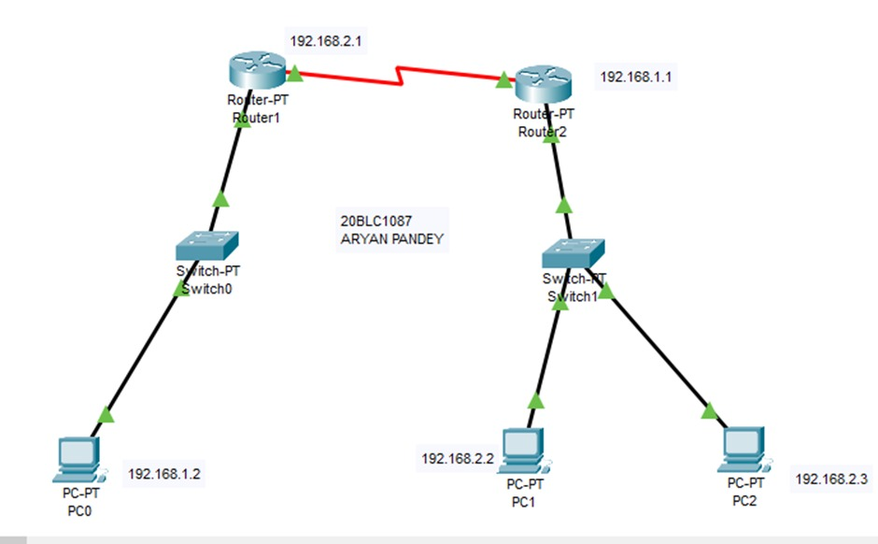

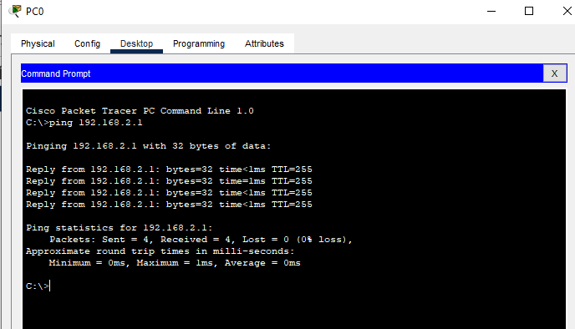

CREATE ACCESS LIST

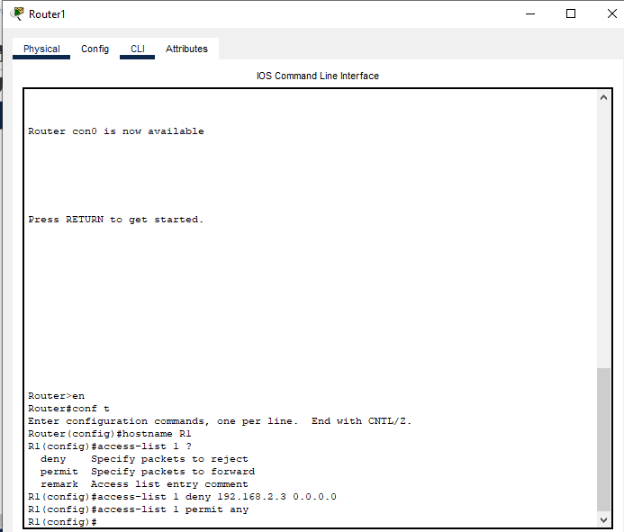

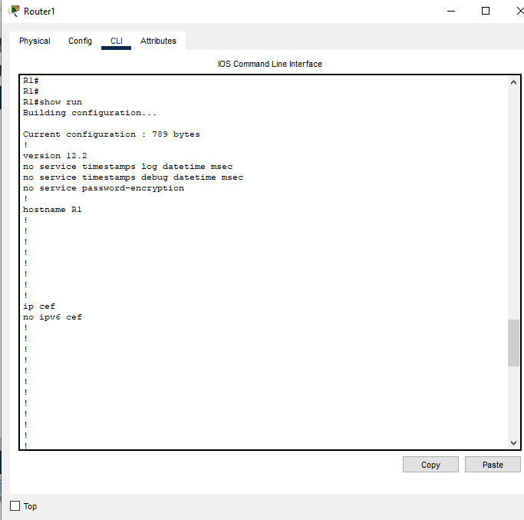

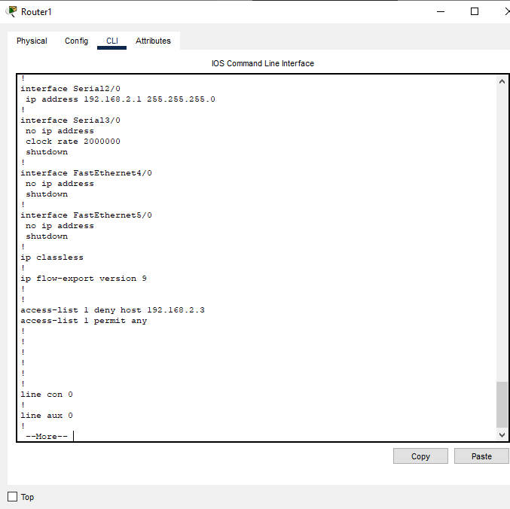

APPLY ACCESS LIST TO AN INTERFACE: -

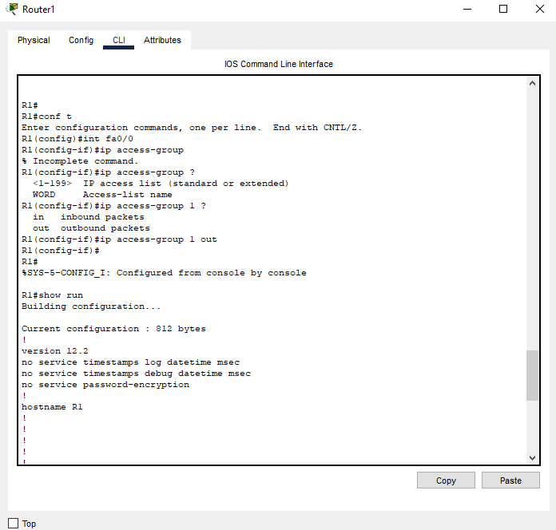

PC1 IS ABLE TO PING PC0: -

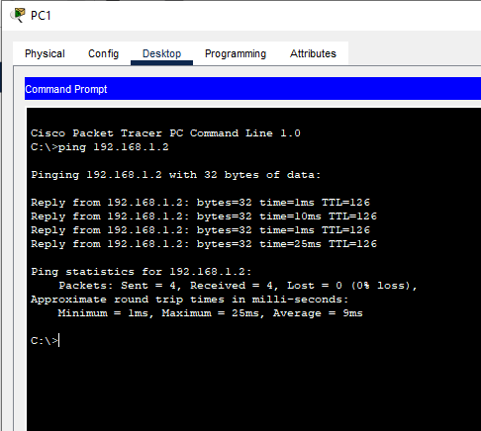

PC2 UNABLE TO PING PC0: -

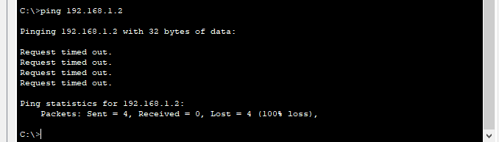

BLOCK ACCESS TO 192.168.2.2 (PC2): -

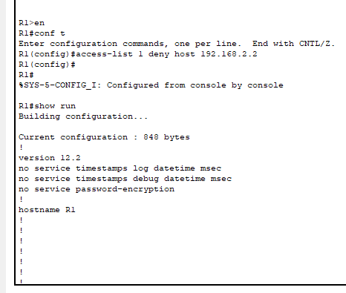

Cannot block as third line will not get executed.  
For access list, add specific statements at the top and most general statements at the bottom.

PC1 still able to connect PC0.

ADDING ONE MORE HOST TO THE NETWORK: -

ACCESS LIST IS NOW NOT AVAILABLE: -

CREATING NEW ACCESS LIST: -

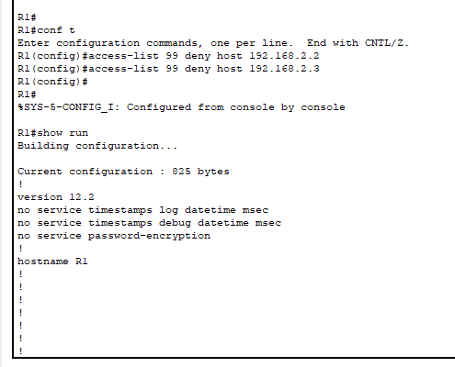

NEW ADDED PC3 UNABLE TO ACCESS PC0: -

HOST IS ABLE TO PING PC0: -

ADDING ONE MORE NETWORK TO ROUTER1: -

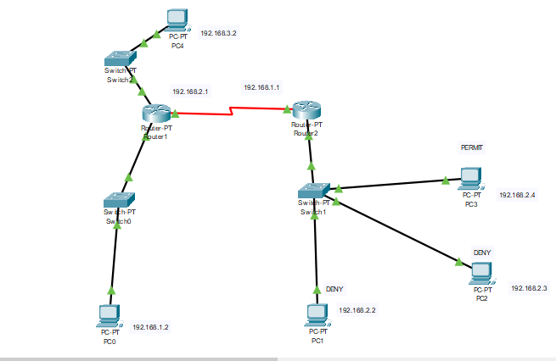

PC 3 ABLE TO PING PC4: -

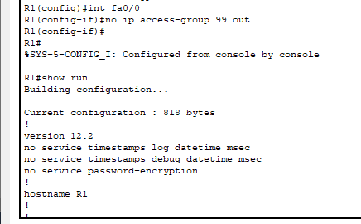

ACCESS LIST NO LONGER APPLIED: -

**Part 2: -**

**EXTENDED ACL**

APPLIED CLOSEST TO THE SOURCE: -

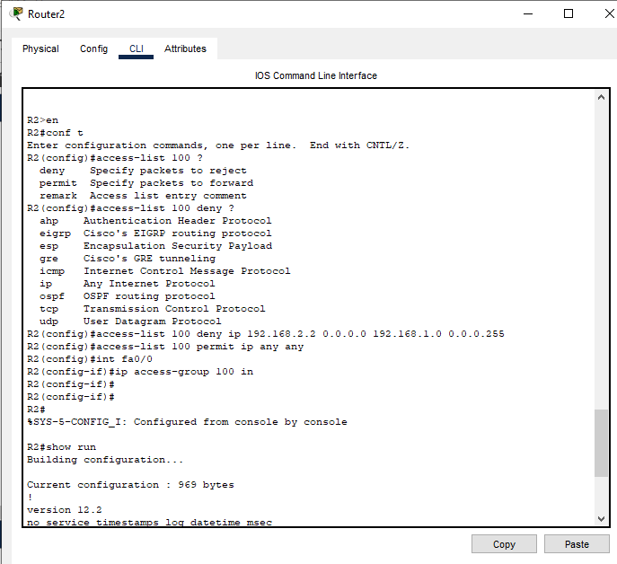

DESTINTION HOST NOT REACHEABLE: -

EXTENDED ACL: -  
DENIES OR PERMITS SOURCE IP ADDRESS, DETINATION IP ADDRESS, PORT(SERVICE): -

ADDING SERVER TO THE NETWORK: -

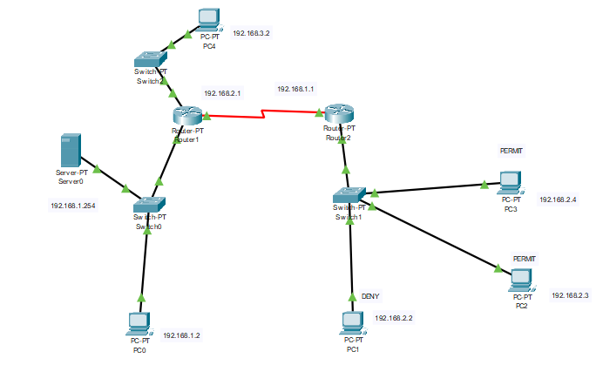

DENYIING ACCESS TO PC0 AND GIVING ACCESS TO SERVER: -

SERVER IS REACHABLE AND PC0 IS UNREACHABLE FROM PC1: -

Result: -

Configuration of standard and extended Access List using Cisco Packet Tracer.